AI FAQ ASSISTANT
AI-Powered FAQ and Customer Support Automation
Project Documentation
Node.js • Express.js • MongoDB • Mongoose • JWT • bcrypt • Google Gemini

1. Project Overview
AI FAQ Assistant is a secure REST API designed to manage frequently asked questions and support customer-service operations. The system allows users to register and log in, create and manage FAQs, search FAQ content, and use AI to generate FAQ content.

2. Purpose of the Project
The main purpose is to reduce repetitive customer-support work by storing common questions and answers in one place. Users can search the FAQ database and quickly obtain the relevant answer. The project also provides authentication and role-based access for secure FAQ management.

3. Technologies Used
- Node.js – backend runtime
- Express.js – REST API framework
- MongoDB – database
- Mongoose – MongoDB object modeling
- JWT – authentication
- bcrypt – password hashing
- Google Gemini – AI FAQ generation
- Postman – API testing
- Visual Studio Code – development environment

4. Project Structure
The project follows a simple MVC-style structure. The src folder contains configuration, middleware, models, routes, and application/server files. The Postman collection is stored separately for API testing.
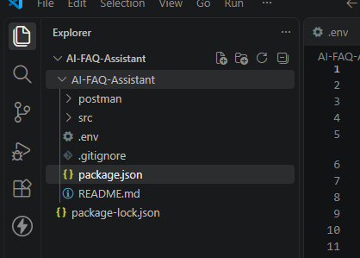
Figure 1: AI FAQ Assistant project structure in Visual Studio Code.

5. Environment and Server Setup
The project uses a .env file for the server port, MongoDB connection, JWT secret, and Gemini API key. The application connects to MongoDB before starting the Express server.
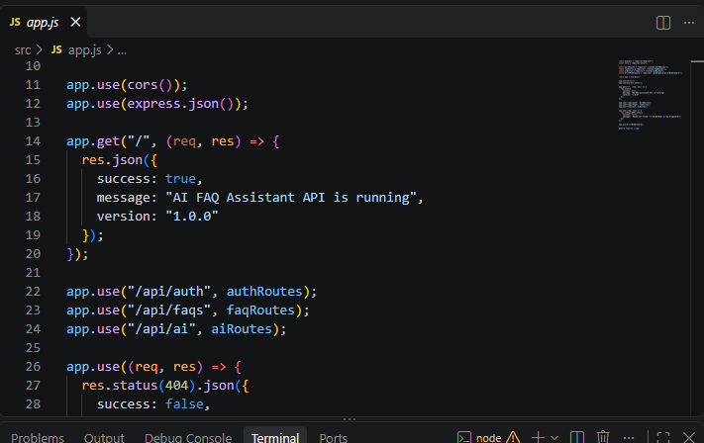
Figure 2: Environment configuration used by the project.
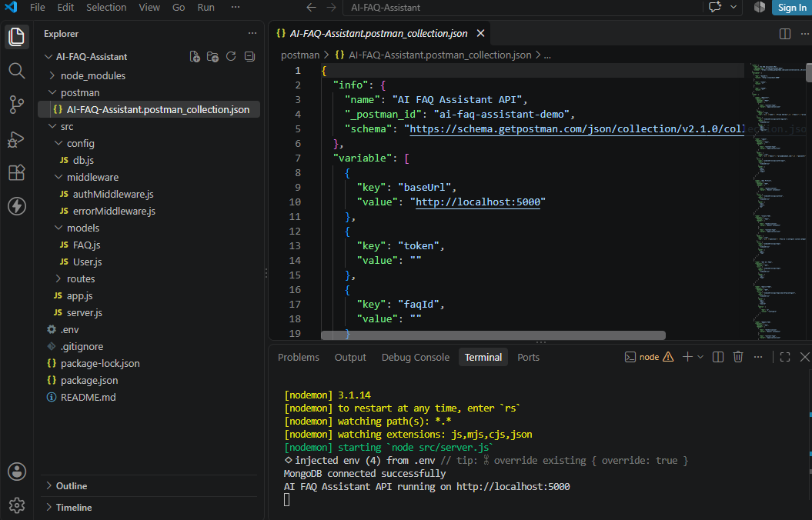
Figure 3: Server running successfully with MongoDB connected.

6. Express Application and API Routes
The Express application enables CORS and JSON request handling and connects the main route groups. The API is organized into authentication, FAQ, and AI routes.
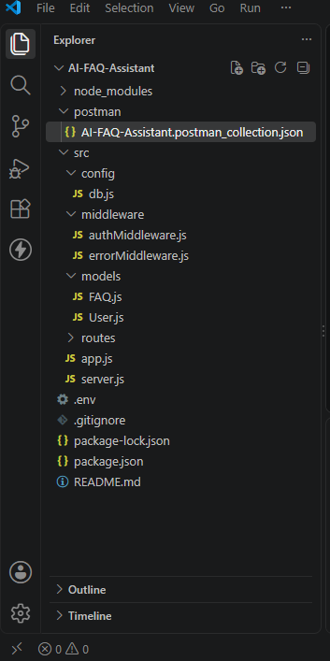
Figure 4: Main Express application routes in app.js.

7. API Endpoints
Method | Endpoint | Purpose
POST | /api/auth/register | Register a new user
POST | /api/auth/login | Authenticate a user and receive a JWT
GET | /api/auth/me | Get the authenticated user's profile
POST | /api/faqs | Create a new FAQ
GET | /api/faqs | Get all FAQs
GET | /api/faqs/search?q=... | Search FAQs by question/answer/category
PUT | /api/faqs/:id | Update an FAQ
DELETE | /api/faqs/:id | Delete an FAQ
POST | /api/ai/generate-faq | Generate FAQ content using Gemini

8. User Registration
A user can register through the authentication API by providing a name, email address, and password. The successful response confirms registration and returns an authentication token.
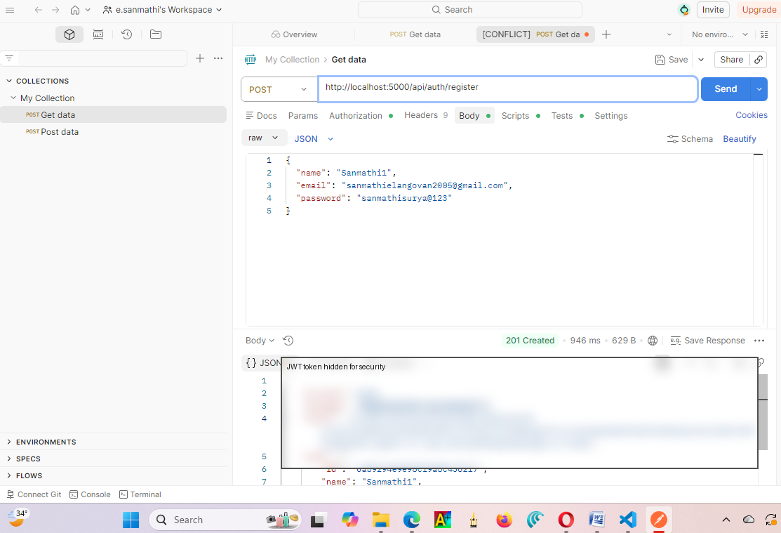
Figure 5: Successful user registration in Postman. The JWT token is hidden in this document for security.

9. User Login and Authentication
After registration, the user can log in using the registered email and password. A successful login returns a JWT token. The token is used to access protected operations such as FAQ creation.
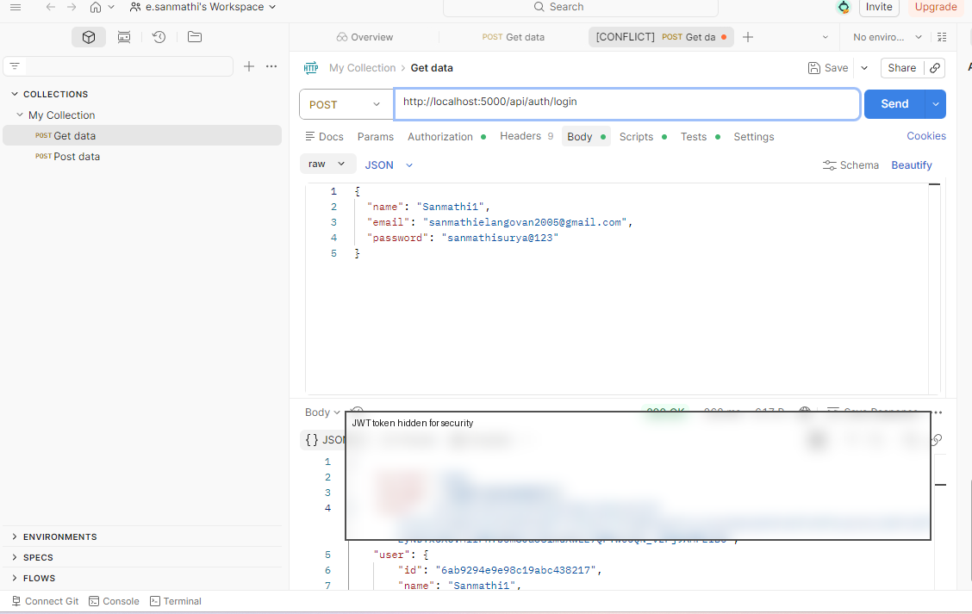
Figure 6: Successful login response in Postman. The JWT token is hidden for security.
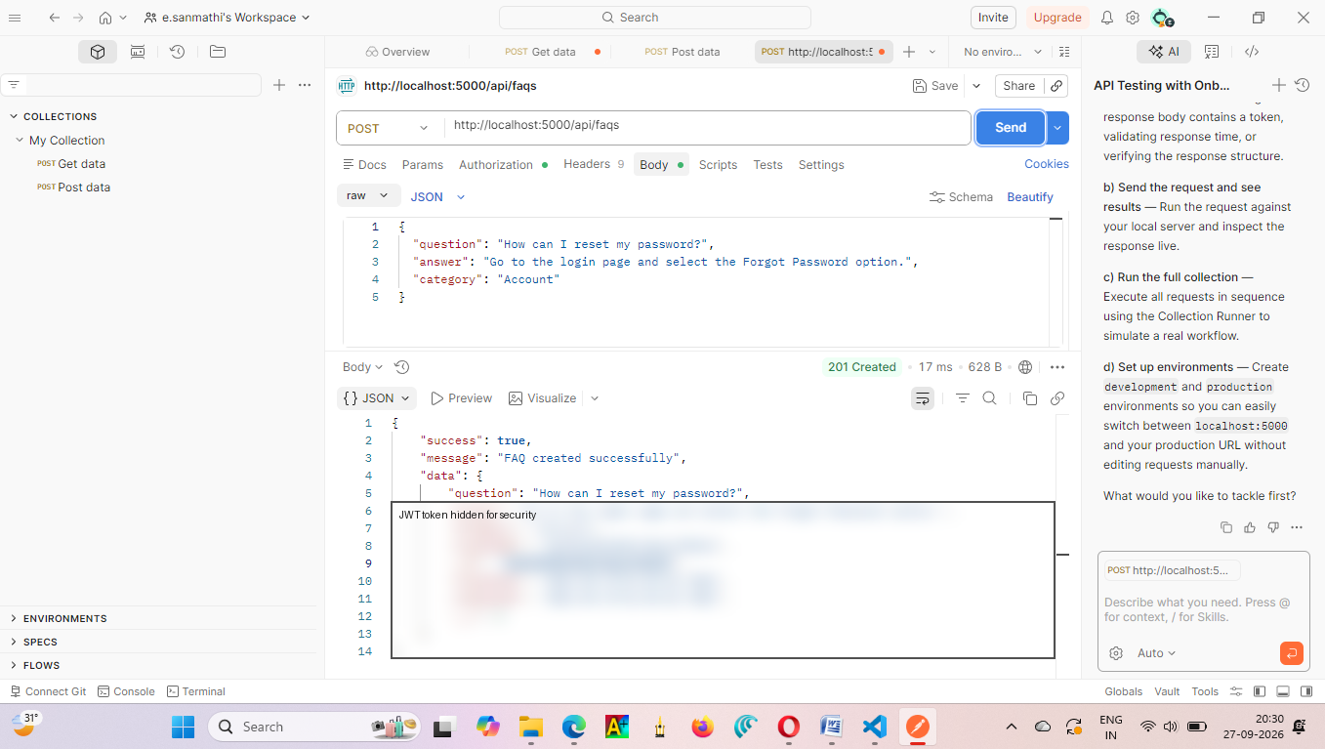
Figure 7: Login response showing successful authentication. The JWT token is hidden for security.

10. Creating an FAQ
An authenticated user can create an FAQ by sending a question, answer, and category. The API stores the FAQ in MongoDB and records the user who created it.
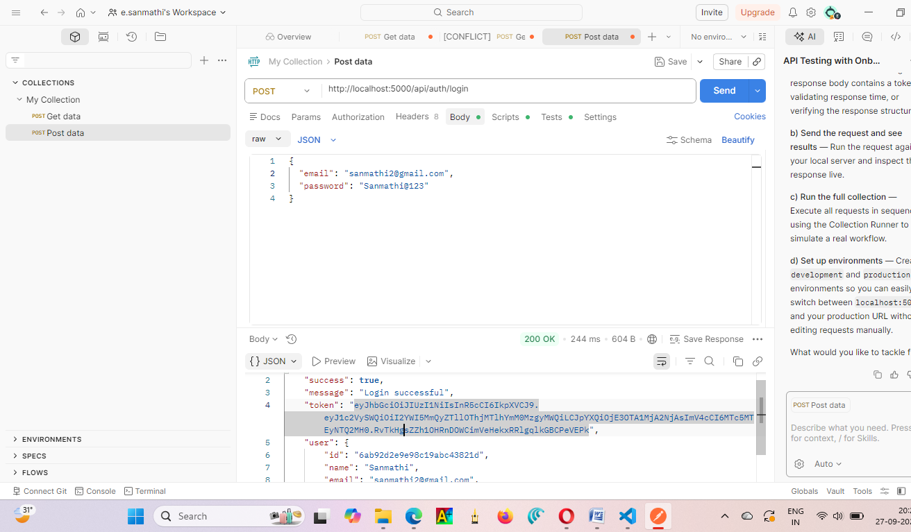
Figure 8: FAQ creation completed successfully with HTTP 201 Created.

11. FAQ Search and Answer Retrieval
The search API allows a user to submit a search phrase through the q parameter. The system searches the stored FAQ content and returns matching FAQ records, including the stored answer. For example, a search related to resetting a password can return the previously created password-reset FAQ.
Example request:
GET http://localhost:5000/api/faqs/search?q=reset%20password

12. AI FAQ Generation
The project also provides an AI endpoint that uses Google Gemini to generate an FAQ from a supplied topic or prompt. The generated result is expected to contain a question, answer, and category. This feature helps reduce the manual effort required to prepare FAQ content.

13. Security Features
- JWT-based authentication for protected API operations.
- bcrypt password hashing before storing user passwords.
- Role-based authorization for administrative/content operations.
- Centralized error handling.
- Environment variables for secrets and API configuration.

14. Conclusion
The AI FAQ Assistant successfully provides a backend system for secure FAQ management and customer-support automation. The tested workflow demonstrates project setup, MongoDB connection, user registration, login authentication, and FAQ creation. The system can be extended with semantic search, a frontend interface, analytics, and additional customer-support features.

Note: JWT tokens visible in the original screenshots have been hidden in this document for security.

